SafeGuard Project Series
Project 1
ScopeGuard
A Beginner-Friendly Guide to the Scope & Target Authorization Engine
Prepared by: Atharva
Domain: Cybersecurity / Ethical Hacking — Red Teaming & Bug Bounty Tooling
Status: Project 1 Complete

1. What Is ScopeGuard? (In Plain Words)
Think of ScopeGuard like a security guard standing at the door of a building before any testing begins. Before you knock on any door (test any target), the guard checks one list: “Am I allowed to be here?” ScopeGuard does exactly this for bug bounty hunting and penetration testing — except the “building” is a website, server, or app, and the “list” is the official rules of a bug bounty program.
In every bug bounty program, the company clearly says which systems you are allowed to test (called the scope) and which systems are off-limits. Testing something that is off-limits — even by accident — can get a researcher banned from a program, or in serious cases, cause legal trouble. ScopeGuard exists purely to prevent that mistake.
In one sentence:
ScopeGuard reads a simple rules file and tells you, with a clear reason, whether a specific target is safe to test or not — before you ever touch it.

2. The Problem It Solves
Bug bounty programs list their rules in plain text on their program page. A program might allow “*.example.com” (any subdomain of example.com) but specifically forbid “admin.example.com”. Reading these rules sounds simple, but in practice people make mistakes constantly, especially when a program has dozens of rules mixed with exceptions.
Common mistakes a human can make when checking this manually:
- Missing an exclusion buried somewhere in the program page
- Confusing a plain hostname with a full URL
- Misreading a wildcard rule (thinking it covers more, or less, than it actually does)
- Forgetting that a very specific rule should override a broader, general rule
- Assuming a target is allowed just because it was mentioned somewhere on the page
- Starting to test before being fully sure the target is authorized
Any one of these mistakes can turn an ethical, well-intentioned test into an unauthorized access incident. ScopeGuard removes the guesswork by turning this judgment call into a consistent, repeatable, and explainable decision.

3. How It Works — The Big Picture
ScopeGuard does not try to read a bug bounty program page automatically — program pages are written in free-form English and can be interpreted in many ways, so a machine reading them directly would be unreliable and risky. Instead, ScopeGuard splits the work sensibly between a human and a program:
- The human (researcher) reads the entire program carefully and understands the intent behind the rules.
- The human writes down the important rules in a simple, structured file (YAML format).
- ScopeGuard takes that structured file and makes fast, consistent, and explainable decisions from it.
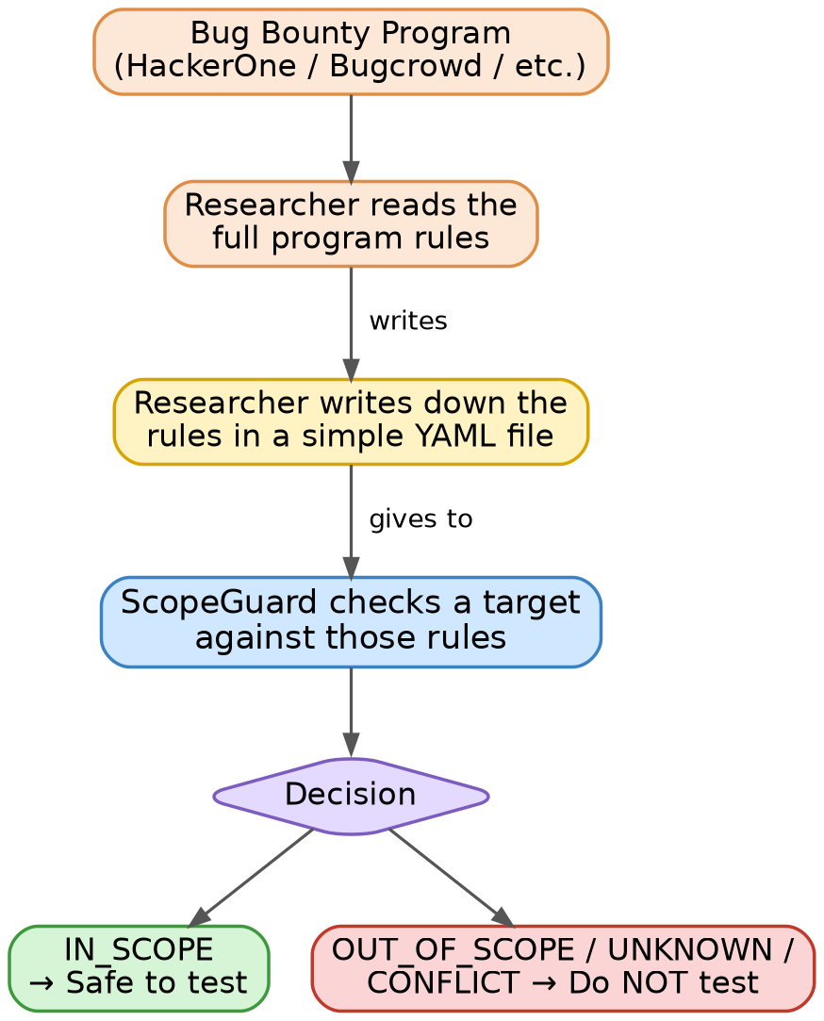
Figure 1: The overall flow, from reading a bug bounty program to getting a testing decision.
This split is intentional and important: humans are good at understanding written intent, while software is good at applying rules consistently without getting tired or careless. ScopeGuard focuses only on the part it can do reliably.

4. The Core Idea: Scope Rules
Every rule ScopeGuard understands is written as a small, structured entry with four main parts: an ID (so it can be referred to), an effect (include or exclude), an asset (the actual target it refers to), and optionally a category or description for clarity.
- id: "S001"
effect: "include"
asset:
type: "hostname"
value: "example.com"

- id: "S002"
effect: "exclude"
asset:
type: "hostname"
value: "admin.example.com"
In plain English, this file says two things:
- “example.com is allowed to be tested” (include)
- “admin.example.com is NOT allowed to be tested, even though it looks related” (exclude)
YAML was chosen for this file because it reads almost like plain English, is easy to edit without knowing how to code, and is a format Python (the language ScopeGuard is built in) can process very reliably.

5. What Kinds of Targets Can It Understand?
ScopeGuard V1 understands six common types of targets that show up in almost every bug bounty program:
Asset Type | What It Looks Like | What It Means
Hostname | example.com | One exact website address
Host Wildcard | *.example.com | Any subdomain of example.com
Exact URL | https://example.com/login | One exact web page or endpoint
URL Path Wildcard | https://example.com/api/* | That path and everything under it
IPv4 Address | 192.168.1.10 | One exact server address
IPv4 Network (CIDR) | 192.168.1.0/24 | A whole range/block of server addresses

6. Making the Right Call When Rules Overlap (Specificity)
Real bug bounty programs often have rules that overlap. For example, a program might broadly allow all subdomains of example.com, but separately exclude one specific subdomain, like the admin panel. When a target matches more than one rule, ScopeGuard needs a fair, predictable way to decide which rule “wins”.
The guiding principle is simple and matches common sense: a rule that names something exactly and specifically should win over a rule that only mentions something broadly and generally.
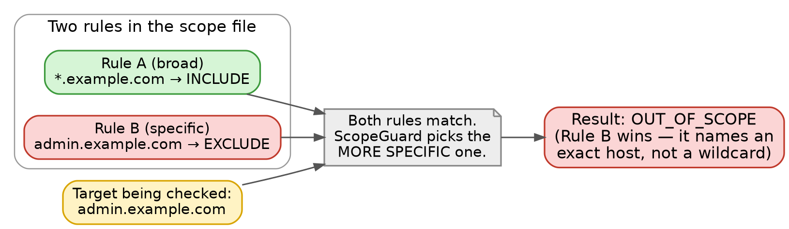
Figure 2: When two rules disagree, the more specific rule always wins — here, the exact hostname rule beats the wildcard.
This same idea of “more specific wins” applies across every asset type ScopeGuard understands:
- An exact hostname beats a wildcard hostname
- An exact URL beats a general URL-path wildcard, and a deeper path wildcard beats a shallower one
- An exact IP address beats a narrower network range, which beats a broader network range

7. What Happens When ScopeGuard Isn't Sure
Not every situation is clear-cut. ScopeGuard is deliberately cautious in these situations, following what security professionals call a “fail-closed” approach — meaning that when in doubt, it always leans toward safety rather than convenience.

7.1 When Rules Directly Contradict Each Other
If two rules are equally specific but disagree — for example, one says a target is included and another equally specific rule says it's excluded — ScopeGuard does not guess or pick one arbitrarily. It reports the result as a CONFLICT and asks the researcher to resolve the contradiction manually.

7.2 When ScopeGuard Cannot Safely Decide
Sometimes a rule includes a special condition that ScopeGuard's first version cannot automatically evaluate. Rather than assuming the target is safe, it returns UNKNOWN, which means “do not proceed until a human checks this.”

7.3 When Nothing Matches At All
If a target doesn't match any rule in the file whatsoever, ScopeGuard does not assume it's allowed just because nobody said otherwise. Silence is treated as “not authorized,” not as permission. This default-deny behavior is one of the most important safety decisions in the entire project.
Why this matters:
A tool that guesses “probably fine” when it isn't sure is dangerous in security work. ScopeGuard is built to always prefer caution: when unsure, it stops and asks a human, rather than assuming it's safe to continue.

8. Decisions You Can Actually Understand
A tool that just says “YES” or “NO” isn't very trustworthy, because you can't tell if it made a mistake. ScopeGuard always explains its reasoning alongside its answer, so every decision can be checked and understood.
For example, checking “example.com” might produce this result:
{
"state": "IN_SCOPE",
"target": "example.com",
"matched_rules": ["S001"],
"winning_rule": "S001",
"reason": "Rule S001 won by specificity"
}
This tells you not just the answer, but exactly which rule caused it and why — which makes the tool easy to trust, debug, and explain to someone else (a teacher, interviewer, or teammate).

9. How the Project Is Built (Architecture)
Behind the scenes, ScopeGuard is organized into small, focused pieces that each do one job well, rather than one giant block of code that does everything. This is a standard, professional way to build software, because it makes each piece easy to test, fix, and extend later.
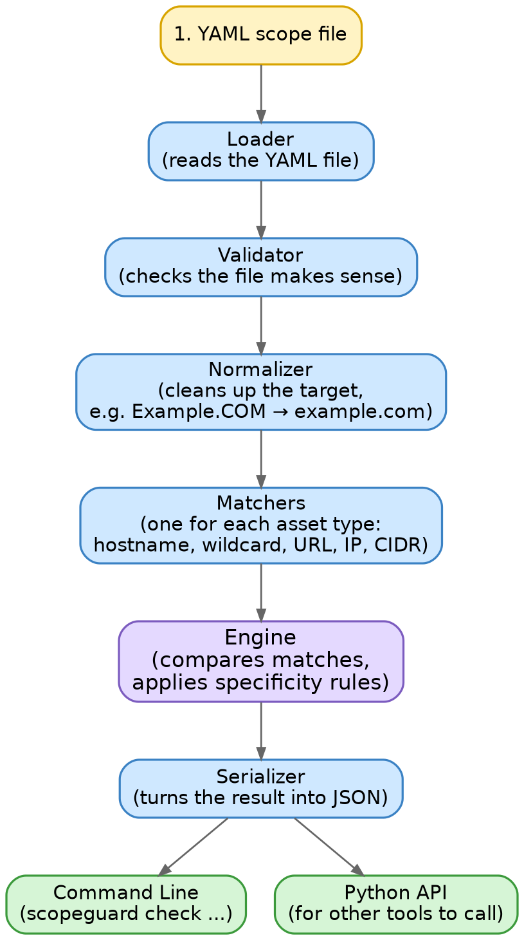
Figure 3: Each stage hands off cleanly to the next — loading, checking, cleaning, matching, deciding, and finally outputting the result.
In short, here is what each piece is responsible for:
- Loader — opens and reads the YAML rules file
- Validator — checks that the file and the target actually make sense before trusting them
- Normalizer — cleans up small differences in how a target might be typed (capital letters, etc.)
- Matchers — one specialist for each asset type, so hostname logic never gets mixed up with IP logic
- Engine — the decision-maker; compares all matches and applies the specificity rules
- Serializer — packages the final decision into JSON so other tools can use it

10. How You Actually Use It
ScopeGuard can be used directly from the command line — no need to write any code:
scopeguard check --scope examples/basic_scope.yaml --target example.com
It can also output its answer as JSON, so that future tools in the SafeGuard series can read the result automatically instead of a human reading plain text:
scopeguard check --scope examples/basic_scope.yaml --target example.com --json
It also returns different exit codes depending on the result (0 for allowed, 1 for not allowed or unclear, 2 for a broken input file) — this is a small detail, but it's what allows ScopeGuard to be safely plugged into automated scripts later in the project series.

11. What's In V1, and What's Deliberately Left Out
It's just as important to be clear about what this first version does NOT do, as it is to explain what it does. Trying to do too much in one version usually means doing everything poorly.

Included in V1
- Reading and validating scope rules from a YAML file
- Understanding 6 different types of targets (hostnames, wildcards, URLs, paths, IPs, IP ranges)
- Deciding IN_SCOPE / OUT_OF_SCOPE / UNKNOWN / CONFLICT with a clear reason
- A command-line tool and a JSON output mode
- A reusable Python library so future tools can call it directly
- Automated tests to make sure the logic keeps working correctly

Intentionally NOT in V1
- Automatically reading bug bounty program pages (a human still reads and transcribes the rules)
- Any scanning, reconnaissance, or vulnerability testing
- Exploiting anything or interacting with real targets at all
ScopeGuard's only job is the authorization decision — everything else belongs to later projects in the series, which are described next.

12. Where ScopeGuard Fits in the Bigger Picture
ScopeGuard is Project 1 of a 10-project series called SafeGuard, where each project builds one stage of a responsible, well-structured penetration testing / bug bounty workflow. ScopeGuard forms the safety foundation: nothing in the later projects is allowed to run against a target until ScopeGuard has confirmed it's authorized.
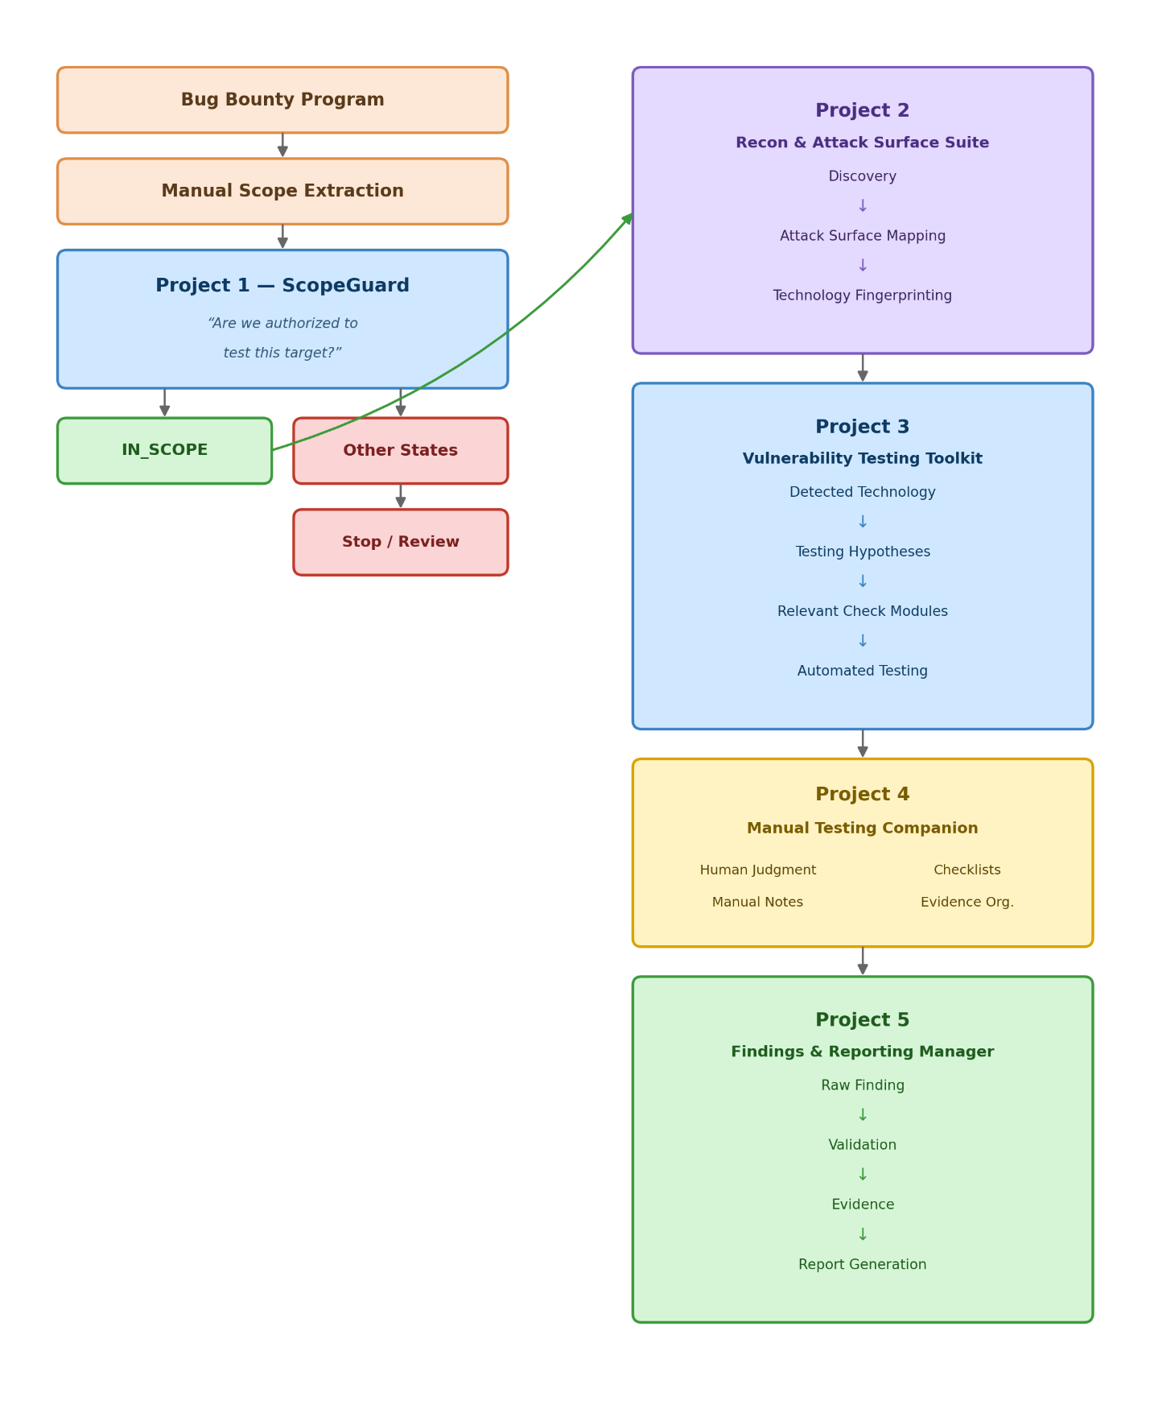
Figure 4: The full SafeGuard roadmap — ScopeGuard is the completed first step that every later project depends on.

13. Key Takeaway
The one idea to remember:
ScopeGuard doesn't look for vulnerabilities — it answers a single, critical question before any testing begins: “Am I actually authorized to test this?” Every other project in this series builds on top of that answer.
This foundation matters more than it might seem at first. In real-world red teaming and bug bounty work, professionalism and staying inside authorized boundaries are exactly what separate ethical researchers from attackers — and building that discipline into the very first tool of the series shows that same mindset from the ground up.

